**Import data from MySQL to HDFS using Scoop:**

1. Start MySQL service:

sudo service mysqld start

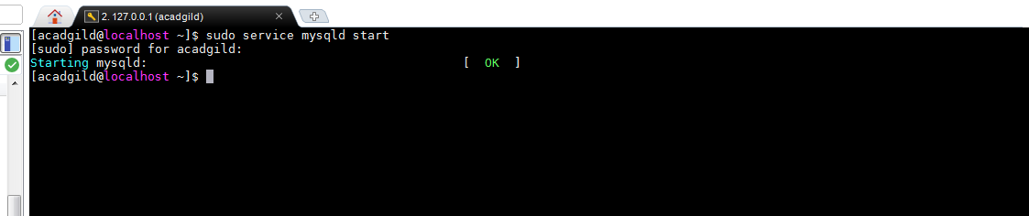

1. Login to the root user:

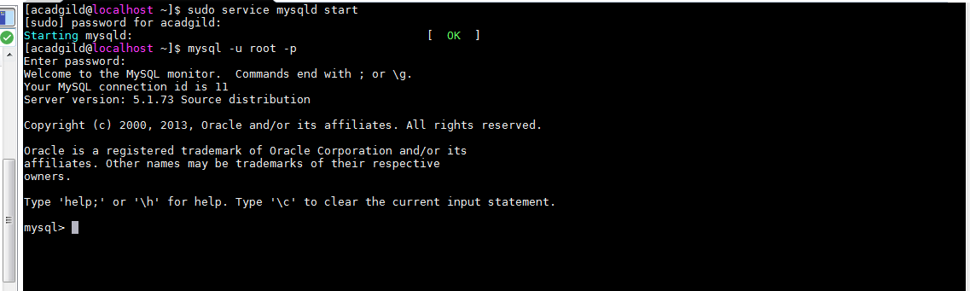

1. Display the databases available:

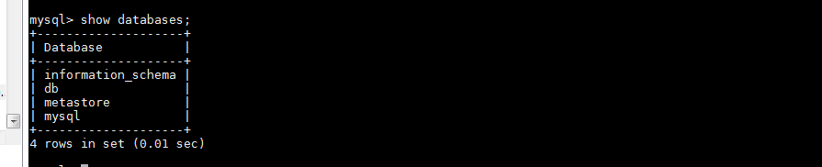

1. Create a database ‘employee’

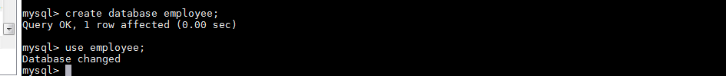

1. Create a table named ‘employeeDetails’

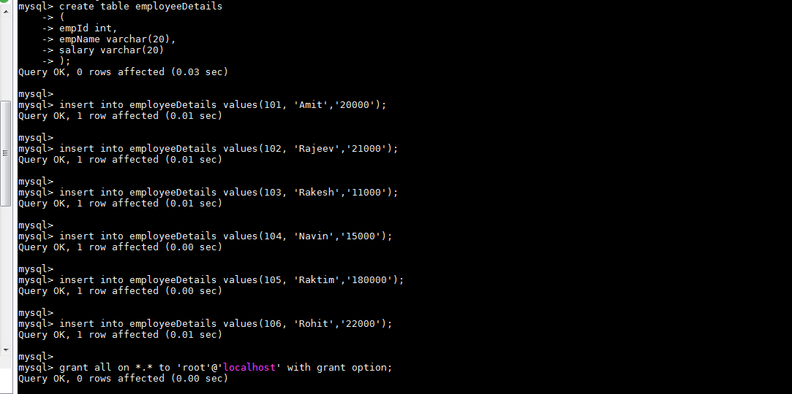

1. Exit from MySQL:



1. Run the sqoop import command to import the data to sqoopout directory in HDFS:

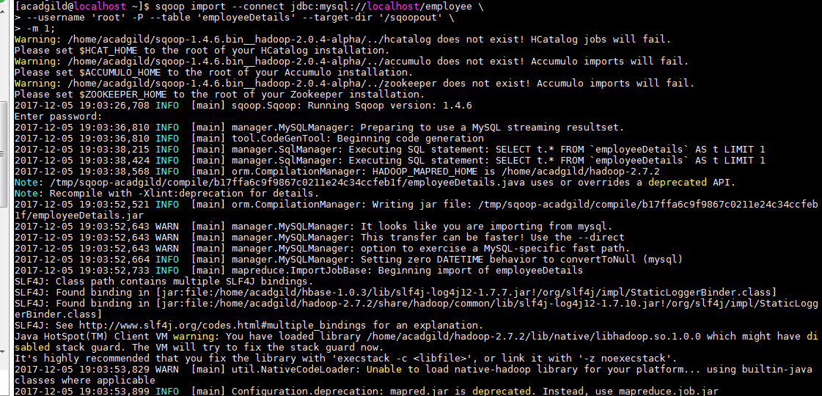

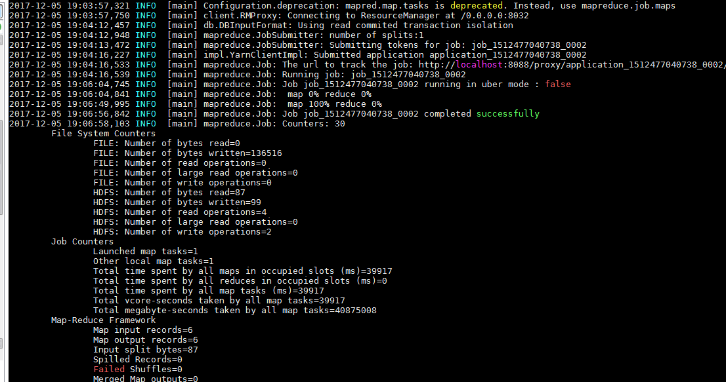

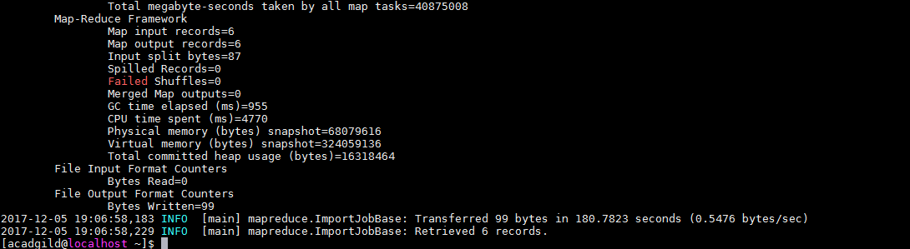

1. View the sqoopout directory. The data has been imported:

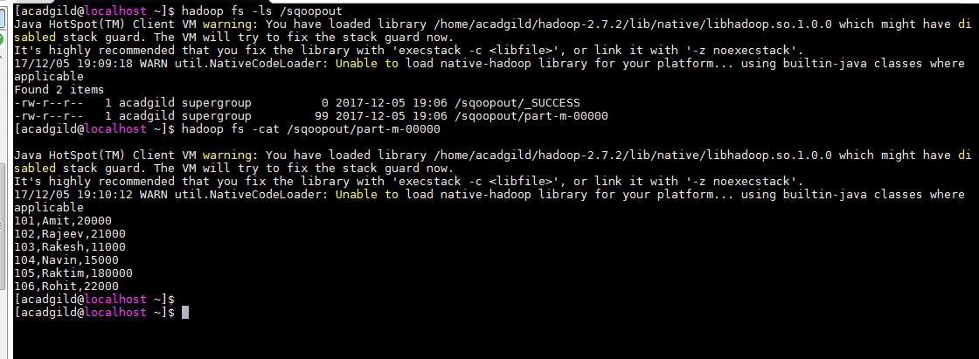

**Export using Sqoop:**

1. Use existing database employee:



1. Create a table employeeExportDetails with schema same as HDFS file:

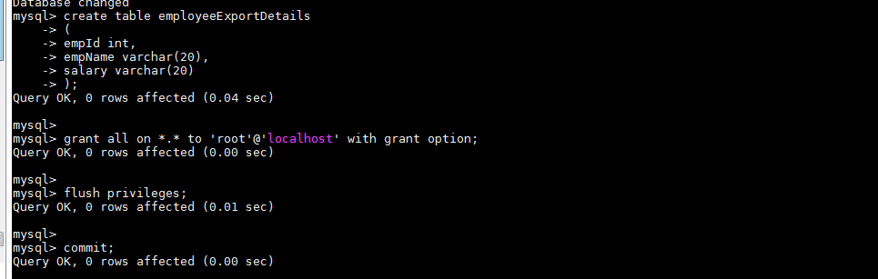

1. Ensure the table is empty:

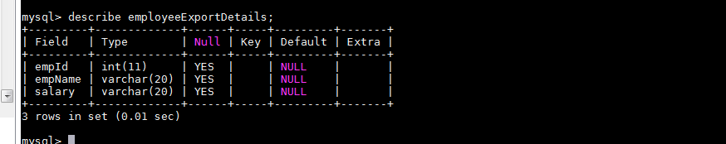

1. View the HDFS file to export data from:

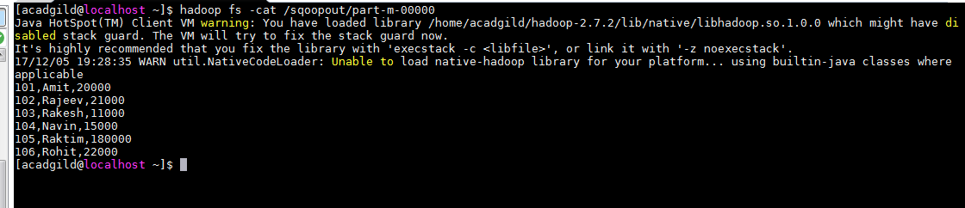

1. Run the Scoop export command to export data to employeeExportDetails table:

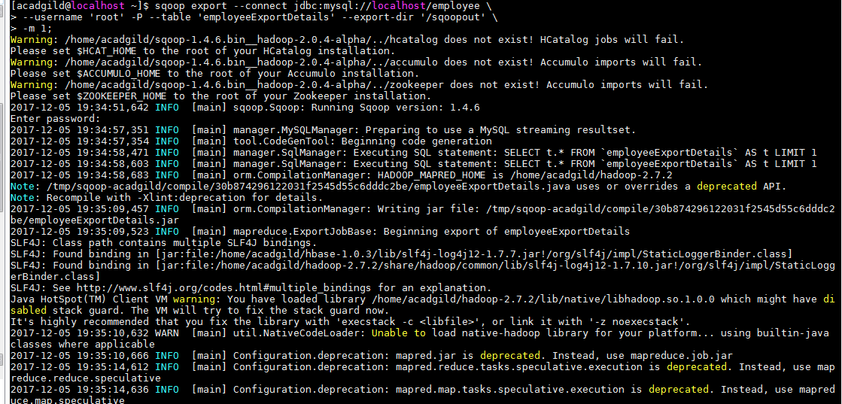

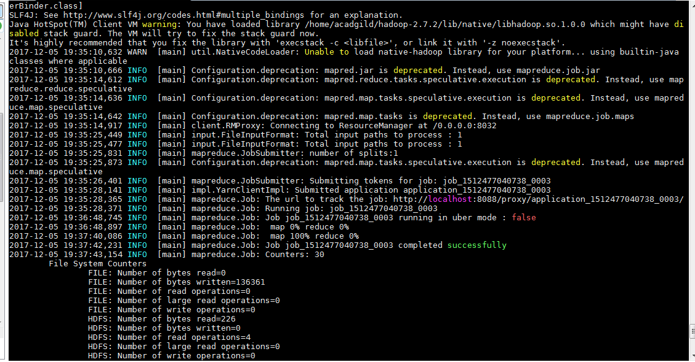

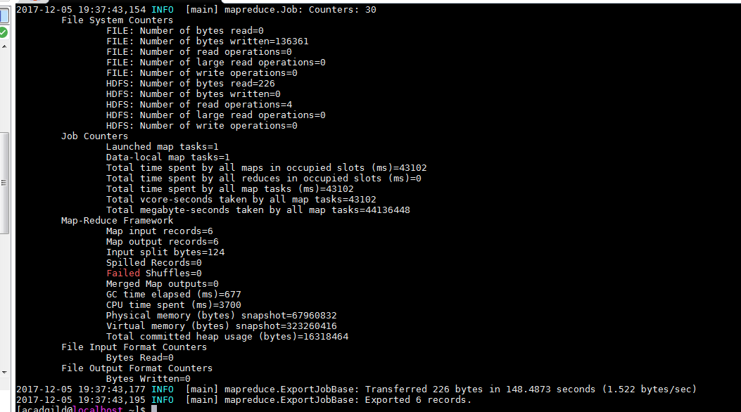

1. Login as root user in MySQL:

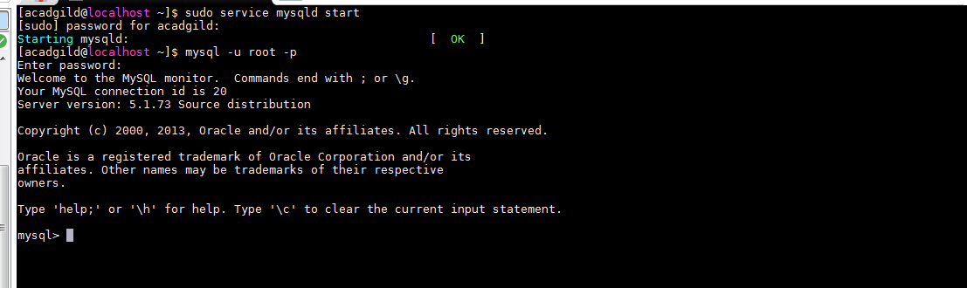

1. View the employeeExportDetails table:

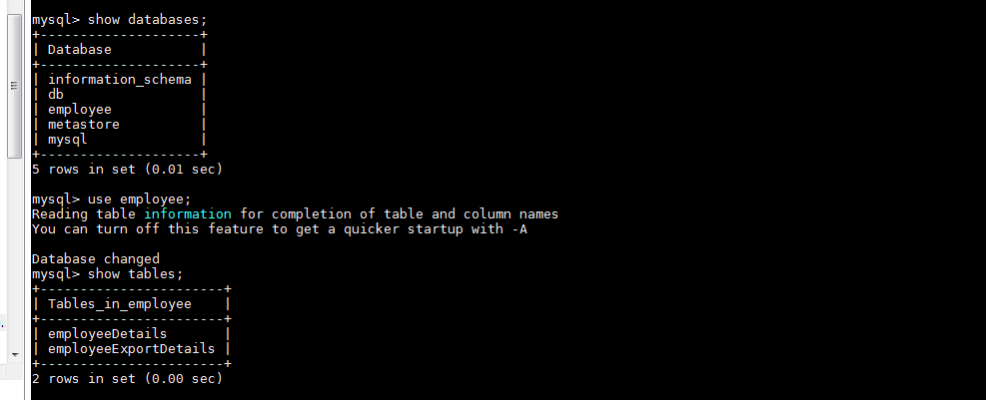

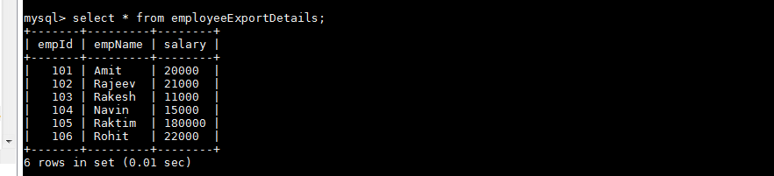

**Transfer data between Mysql and Hive (Import) using sqoop:**

1. Run the Sqoop import command to import data from employeeDetails table to Hive

sqoop import \

--connect jdbc:mysql://localhost/employee \

--username 'root' -P --split-by empId --columns empId,empName \

--table 'employeeDetails' --target-dir '/hiveout' \

--hive-import --create-hive-table --hive-table employee.empHiveDetails \

-m 1;

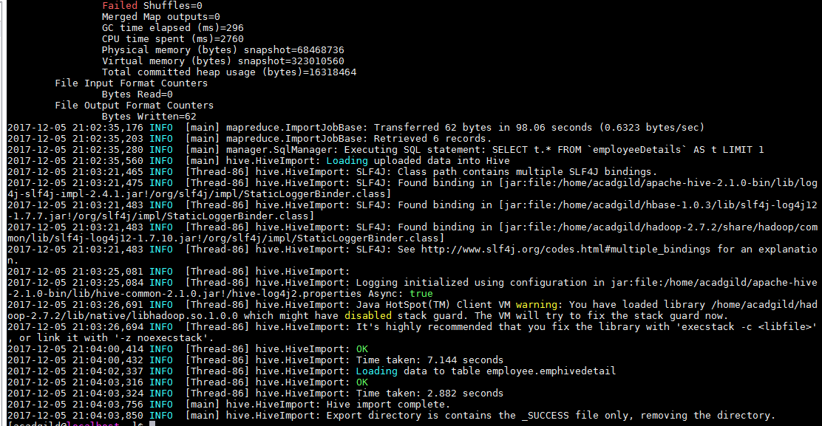

1. Navigate to Hive shell and view the table:

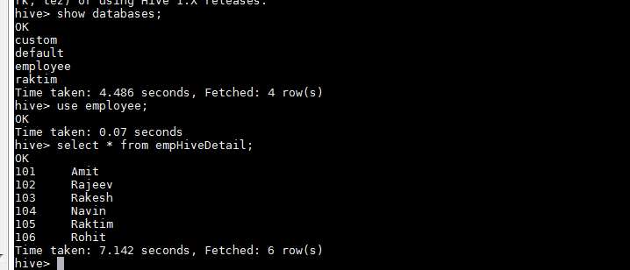

**Transfer data between Mysql and Hive (Export) using sqoop:**

1. Create a table in MySQL:

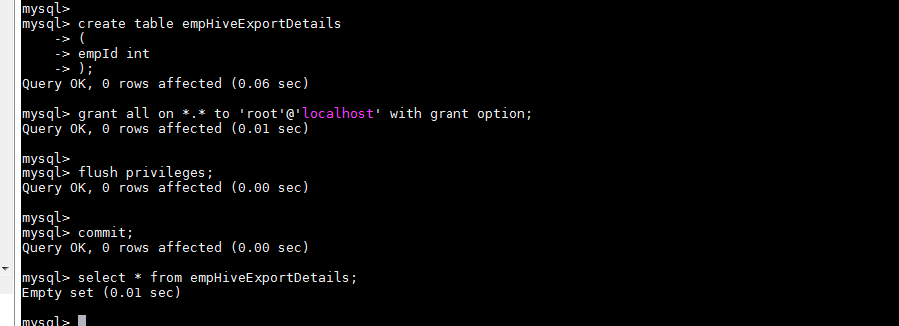

1. Run the export command to export from empHiveDetail table:

sqoop export \

--connect jdbc:mysql://localhost/employee \

--username 'root' -P --columns empId \

--table 'empHiveExportDetails' --export-dir '/hiveout/empHiveDetail' \

--input-fields-terminated-by ',' \

-m 1;